Form insurance type

Form ini sebagai sarana untuk memasukkan dan merubah data tipe asuransi yang ada.

Penampakannya :

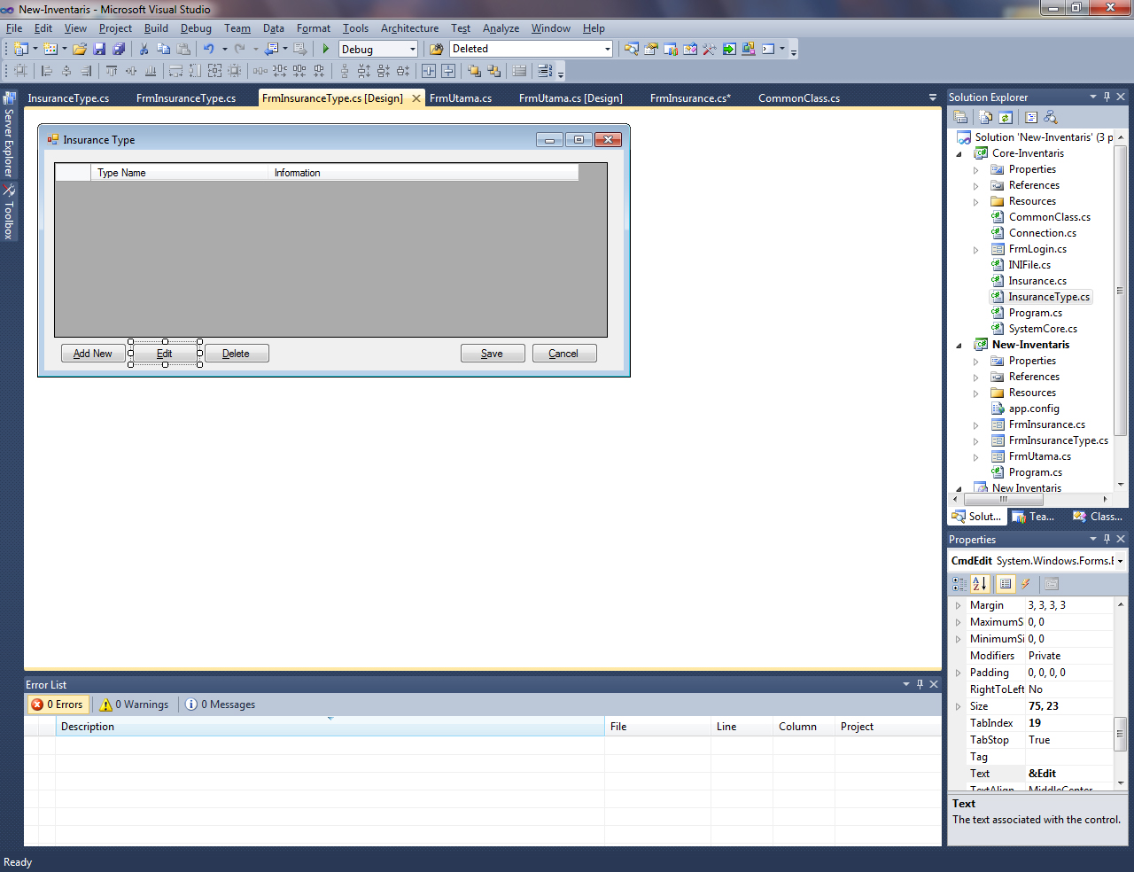

This is coding :

using System;

using System.Collections.Generic;

using System.ComponentModel;

using System.Data;

using System.Drawing;

using System.Linq;

using System.Text;

using System.Windows.Forms;

using Core_Inventaris;

namespace New_Inventaris

{

public partial class FrmInsuranceType : Form

{

// variable definition

InsuranceType InsuranceType = new InsuranceType();

private Connection Connection = new Connection();

private List<InsuranceTypeData> InsDatas;

private Boolean Edit;

private string Deleted;

public FrmInsuranceType()

{

InitializeComponent();

// connect to database server

if (!InsuranceType.toServer())

{

this.Close();

}

else

{

this.Grid.Location = new Point(12, 12);

refreshData();

}

Edit = false;

Grid.Focus();

Deleted = "";

}

public void refreshData()

{

// get all insurance data and display in grid

InsDatas = InsuranceType.getData();

Grid.Rows.Clear();

foreach (var data in InsDatas)

{

Grid.Rows.Add(new string[] { data.Id, data.TypeName, data.Explain });

}

}

public void button(bool Status)

{

// button visible

CmdAdd.Visible = Status;

CmdEdit.Visible = Status;

CmdDelete.Visible = Status;

Grid.Visible = Status;

CmdSave.Visible = !Status;

CmdCancel.Visible = !Status;

}

private void FrmInsuranceType_Load(object sender, EventArgs e)

{

button(true);

}

private void CmdAdd_Click(object sender, EventArgs e)

{

button(false);

TxtId.Text = string.Format("type-{0:D4}", InsDatas.Count + 1);

}

private void CmdCancel_Click(object sender, EventArgs e)

{

button(true);

refreshData();

}

private void CmdEdit_Click(object sender, EventArgs e)

{

// editing mode

if (Deleted != "")

{

foreach (var InsType in InsDatas)

{

if (InsType.Id == Deleted)

{

TxtId.Text = InsType.Id;

TxtName.Text = InsType.TypeName;

TxtExplain.Text = InsType.Explain;

}

}

button(false);

Edit = true;

TxtId.Enabled = false;

}

}

private void CmdDelete_Click(object sender, EventArgs e)

{

//command delete data

if (Deleted != "")

{

if (MessageBox.Show("Are sure to delete this data?", "Delete", MessageBoxButtons.OKCancel) == System.Windows.Forms.DialogResult.OK)

{

InsuranceType.deleteData(Deleted);

refreshData();

}

}

}

private void Grid_CellClick(object sender, DataGridViewCellEventArgs e)

{

Deleted = Grid.Rows[e.RowIndex].Cells[0].Value.ToString();

}

private void CmdSave_Click(object sender, EventArgs e)

{

//saving and updating data

if (!Edit)

{

InsuranceType.insertData(TxtId.Text, TxtName.Text, TxtExplain.Text);

}

else

{

InsuranceType.updatetData(TxtId.Text, TxtName.Text, TxtExplain.Text);

}

refreshData();

button(true);

clearField();

}

public void clearField()

{

TxtId.Text = "";

TxtName.Text = "";

TxtExplain.Text = "";

}

}

}